**QUOTATION**

Quotation no: IDS Technology 113

Date 17/05/2022

**To**

**IDS Technology,**

**Belgaum**

Dear Sir,

Kindly check the quotation as per your requirement.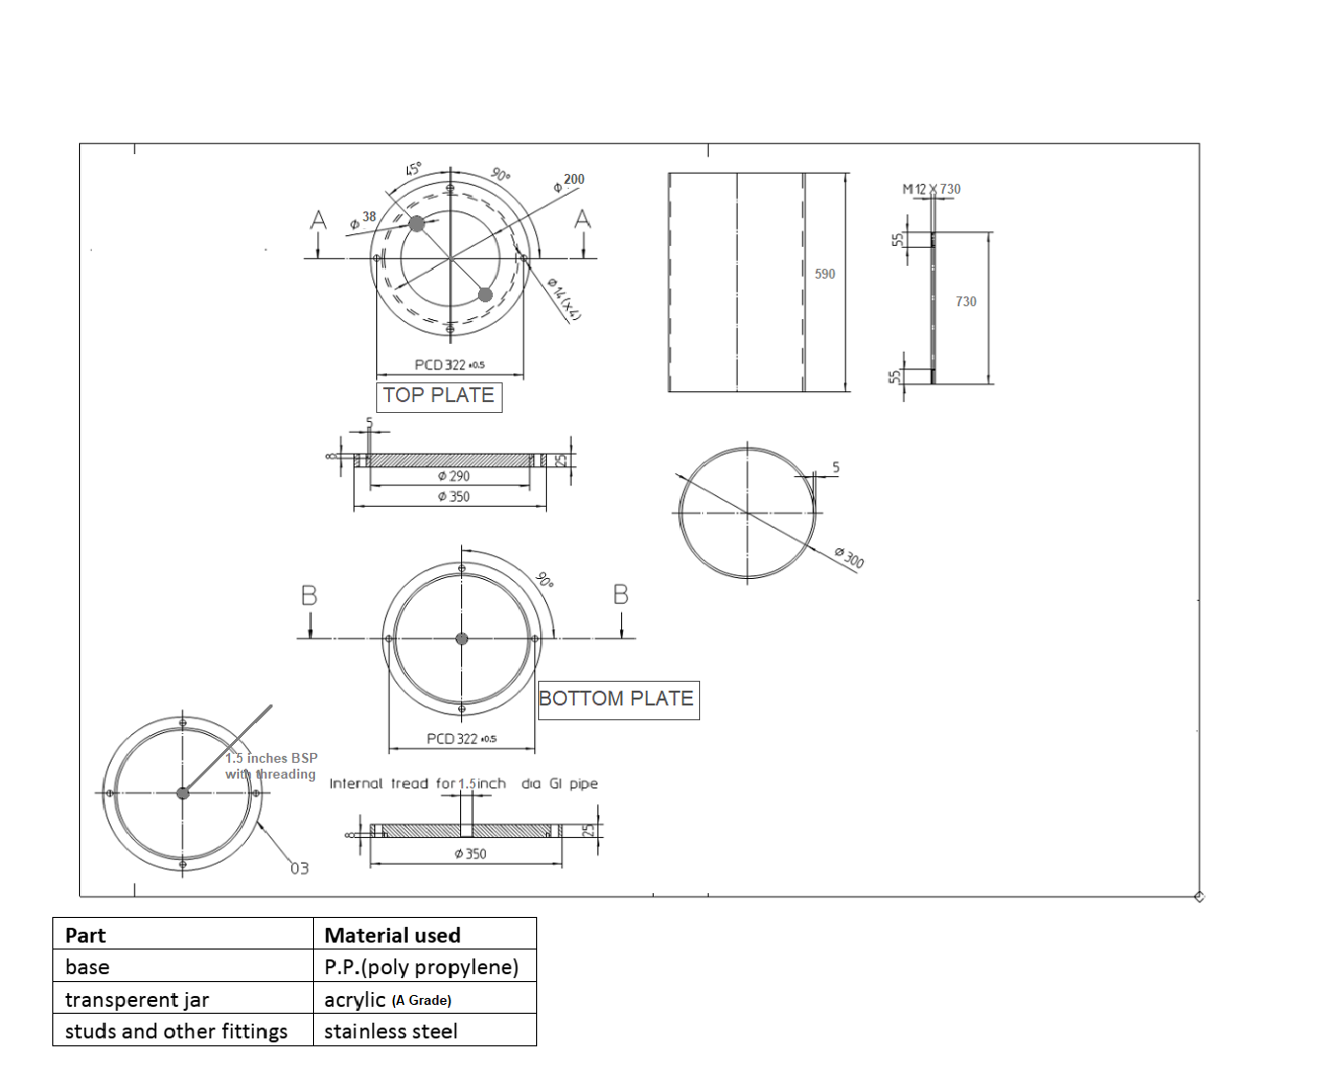

|  |  |  |
| --- | --- | --- |
| **ITEM DESCRIPTION** | **QTY** | **PRICE PER NO. For MOQ 4 NOS** |
| 30 Ltrs Admixture Tank as per layout | 1 | 19600 |

**Scope of work:**

Supply item.

**Payment Terms**

100 % Advance

**Terms & conditions apply**.

Quotation valid for 10 days only.

Lead time 3 weeks from the date of Advance.

GST @ 18% EXTRA

Any extra item if required to be charged as actual.

Supply item only.

Logistic charges to be charged as actuals.

No warranty guarantee.

Physical damage if any to be reported on the day of supply only.